Lab:
- Use a two-dimensional array to solve the following problem.
A company has four salespeople (1 to 4) who sell five different products (1 to 5).
Once a day, each salesperson passes in a slip for each different type of product sold. Each slip contains:
  - The salesperson number
  - The product number
  - The total dollar value of that product sold that day
Thus, each salesperson passes in between 0 and 5 sales slips per day. Assume that the information from all of the slips for last month is available. Write a program that will read all this information for last month’s sales and summarize the total sales by salesperson by product. All totals should be stored in the two-dimensional array sales. After processing all the information for last month, print the results in tabular format with each column representing a particular salesperson and each row representing a particular product. Cross total each row to get the total sales of each product for last month; cross total each column to get the total sales by salesperson for last month. Your tabular printout should include these cross totals to the right of the totaled rows and to the bottom of the totaled columns.

- Imagine a mechanical turtle that walks around the room under the control of a C program. The turtle holds a pen in one of two positions, up or down. While the pen is down, the turtle traces out shapes as it moves; while the pen is up, the turtle moves about freely without writing anything. In this problem you’ll simulate the operation of the turtle and create a computerized sketchpad as well.
Use a 50-by-50 array floor which is initialized to zeros. Read commands from an array that contains them. Keep track of the current turtle position at all times and whether the pen is currently up or down. Assume that the turtle always starts at position 0, 0 of the floor with its pen up. The set of turtle commands your program must process are shown in Fig. Suppose that the turtle is somewhere near the center of the floor. The following “program” would draw and print a 12-by-12 square:
2
5,12
3
5,12
3
5,12
3
5,12
1
6
9
As the turtle moves with the pen down, set the appropriate elements of array floor to 1s. When the 6 command (print) is given, wherever there’s a 1 in the array, display an asterisk, or some other character you choose. Wherever there’s a zero, display a blank. Write a program to implement the turtle graphics capabilities discussed here. Write several turtle graphics programs to draw interesting shapes. Add other commands to increase the power of your turtle graphics language.
Command Meaning
1 Pen up
2 Pen down
3 Turn right
4 Turn left
5, 10 Move forward 10 spaces (or a number other than 10)
6 Print the 50-by-50 array
9 End of data (sentinel)
#include <iostream>
using namespace std;

int main() {
const int SIZE = 50;
int floor[SIZE][SIZE] = {0};
int x = 0, y = 0;
int dir = 0;
bool penDown = false;
int command, steps;

int dx[4] = {0, 1, 0, -1};
int dy[4] = {1, 0, -1, 0};

while (true) {
cin >> command;

if (command == 9)
break;

switch (command) {
case 1:
penDown = false;
break;
case 2:
penDown = true;
break;
case 3:
dir = (dir + 1) % 4;
break;
case 4:
dir = (dir + 3) % 4;
break;
case 5:
cin >> steps;
for (int i = 0; i < steps; i++) {
x += dx[dir];
y += dy[dir];
if (x < 0) x = 0;
if (y < 0) y = 0;
if (x >= SIZE) x = SIZE - 1;
if (y >= SIZE) y = SIZE - 1;
if (penDown)
floor[x][y] = 1;
}
break;
case 6:
for (int i = 0; i < SIZE; i++) {
for (int j = 0; j < SIZE; j++) {
if (floor[i][j] == 1)
cout << "*";
else
cout << " ";
}
cout << endl;
}
break;
default:
cout << "Invalid command!" << endl;
break;
}
}

return 0;
}

- A class contains 3 students each study 4 subject, it is required:
Sum of each student
Average of each subject
Student Ranked 1st in the class

- Write a program that inputs a line of text into char array s[100]. Output the line in alternate uppercase letters and lowercase letters.
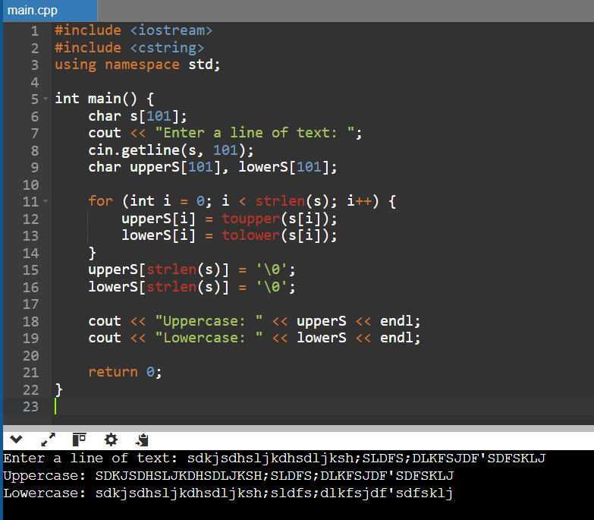

- Write a program that inputs six strings that represent integers, converts the strings to integers, and calculates the sum and average of the six values.
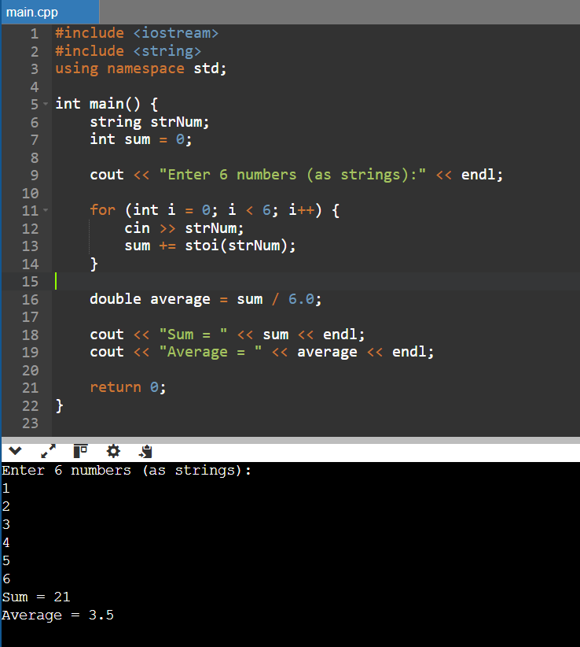

- Line Editor
#include <iostream>
- #include <ncurses.h>
- #include <cctype>
- using namespace std;

- int main() {
- char* line = new char[1];
- int length = 0;
- int capacity = 1;
- int pos = 0;

- int startX = 10;
- int startY = 10;

- initscr();
- cbreak();
- noecho();
- keypad(stdscr, TRUE);

- mvprintw(startY - 2, startX, "Type here (dynamic allocation):");

- while (true) {
- move(startY, startX);
- for (int i = 0; i < length; i++)
- addch(line[i]);
- clrtoeol();
- move(startY, startX + pos);
- refresh();

- int ch = getch();

- if (ch == 27) // ESC
- break;

- switch (ch) {
- case KEY_LEFT:
- if (length > 0)
- pos = (pos - 1 + length) % length;
- break;
- case KEY_RIGHT:
- if (length > 0)
- pos = (pos + 1) % length;
- break;
- case KEY_HOME:
- pos = 0;
- break;
- case KEY_END:
- pos = length;
- break;
- case KEY_BACKSPACE:
- case 127:
- if (pos > 0) {
- for (int i = pos - 1; i < length - 1; i++)
- line[i] = line[i + 1];
- length--;
- pos--;
- }
- break;
- case KEY_ENTER:
- case 10:
- case 13:
- endwin();
- cout << "\nYou entered: ";
- for (int i = 0; i < length; i++)
- cout << line[i];
- cout << endl;
- delete[] line;
- return 0;
- default:
- if (isprint(ch)) {
- if (length == capacity) {
- char* newLine = new char[capacity * 2];
- for (int i = 0; i < length; i++)
- newLine[i] = line[i];
- delete[] line;
- line = newLine;
- capacity *= 2;
- }
- for (int i = length; i > pos; i--)
- line[i] = line[i - 1];
- line[pos] = (char)ch;
- pos++;
- length++;
- }
- break;
- }
- }

- endwin();
- delete[] line;
- return 0;
- }

